

# Geotechnical Site Investigation Survey – Field H1550 (S)

Amplus Limited

**Description of works:**

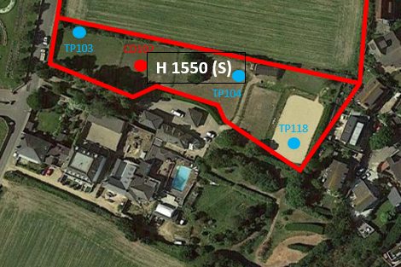We would like to carry out a survey to obtain information on the physical properties of the soil, rock and groundwater in field H1550 (S) adjacent to the Overdale site. This will enable ROKFCC to assess the suitability of material for the construction of the new Hospital and allow us to create an accurate design for the earthworks and foundations. The fieldwork will involve the drilling of exploratory holes using a diesel powered hydraulic track mounted drilling rig and the excavation of trial pits using a diesel driven hydraulic track or wheeled 360deg excavator (backhoe). There will be associated plant and vehicles too. For both the core drilled rotary holes and trial pits, the work area will be fenced off with heras fencing with acoustic lining pads to minimise noise disruption. These works will be intrusive works whereby a rotary drilling geotechnical sample will include drilling a 160 mm hole in the ground down to between 12 – 17 metres in depth, these holes will be filled in after the drilling has finished. The trial pits will be a localised excavation 1 metre wide by 3 metres long and up to 4 metres in depth to obtain soil samples through laboratory analysis and visual inspection.

Fig. 01

The area shown in Fig. 01 above demonstrates the privately owned field that requires surveying for 2 rotary drilled geotechnical sampling and 5 trial pits. Each rotary drilled sample has an allowance of 5 days to complete with each trial pit having 3 days to complete. These days will overlap each other and both activities will be happening concurrently.

Due to the nature of the surveys and any potential below ground areas of Archaeological interest, the contractor will not undertake any rotary drilling until after the outcome of the Geophysical survey due to commence on 17/06/2021 for a duration of 1 week.

**Plant and Equipment:**

To carry out the works within the field (H 1550 (S)) the Casagrande C6 rig will be deployed. This is a steel tracked rig designed to work on terrains of this type but cannot be used on the roadways due to the risk of damage. To mitigate any damage to the roadways and pavements the sub-contractor will use rubber tyres to cover any potential areas susceptible to being damaged. Fig. 02 shows the exact rig due to be used to carry out the rotary drilled geotechnical sampling in the field H 1550 (S).

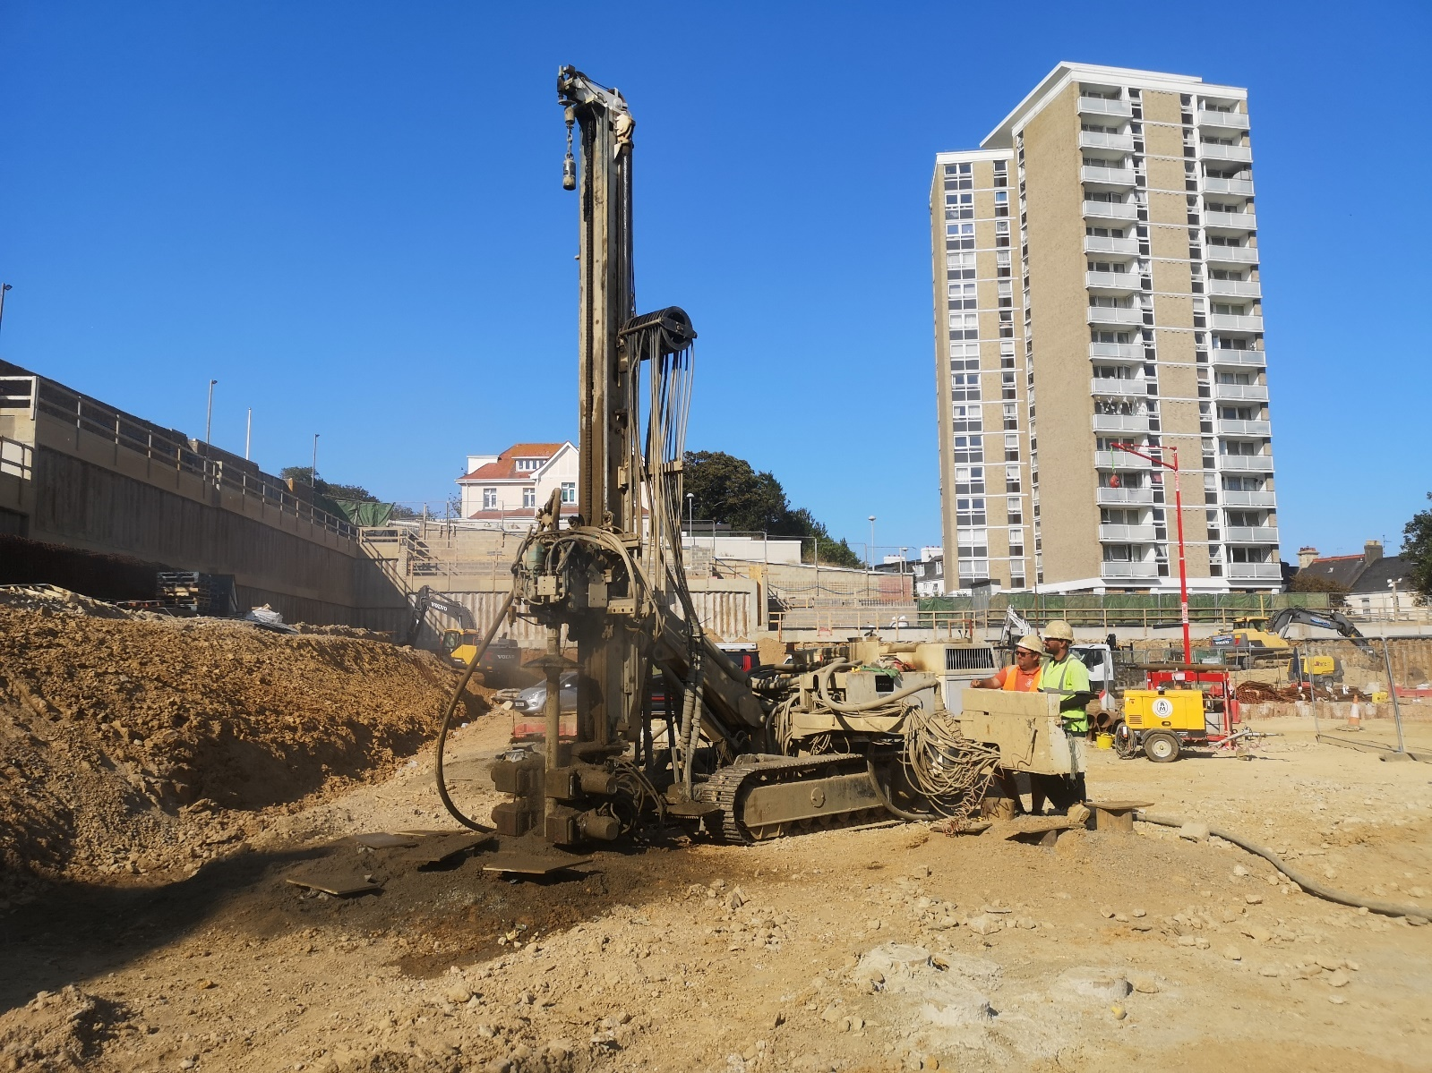

Fig. 02

To carry out the trail pits in field (H 1550 (S)) the contractor will use the Volvo EW140 wheeled excavator, pictured below in Fig. 03. Alternatively if the ground conditions are too wet for the wheeled excavator a steel tracked excavator will be used, as displayed in Fig. 04.

A thorough dilapidation and time & date stamped photographic survey of the field and adjacent access will be conducted by ROKFCCJV before any works take place, this is to ensure that the ground and surrounding areas are re-instated back to the original condition.

All excavations will be fenced off and covered throughout the duration of each trial pit. The fencing will be secured by the contractor at the end of each day. Gary Bennett who is the ROKFCC Health & Safety Manger will carry out an end of shift inspection daily to ensure the excavations are safe and secure.

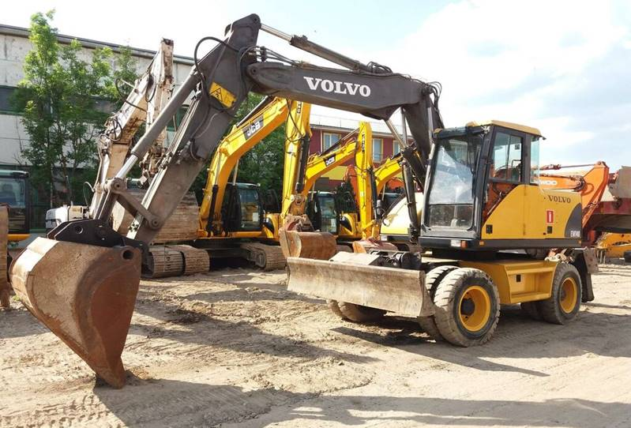

Fig. 03

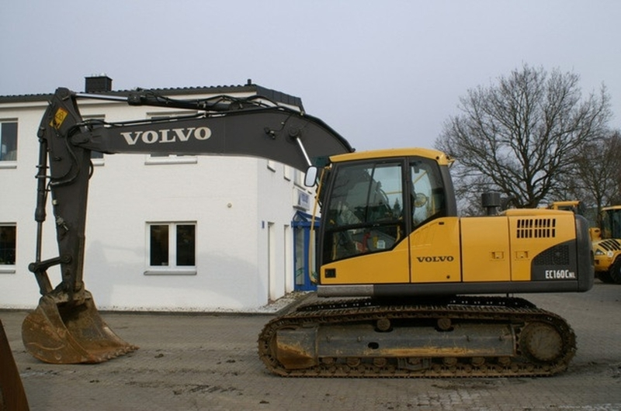

Fig. 04

**Duration:**

The duration of the survey in field H 1550 (S) will take approx. 10 days.

The proposed survey working times are between 08:00AM and 17:00PM Monday to Friday.

No works will be undertaken on Saturdays or Sundays

ROKFCC have already alerted the neighbours to the survey works and they will continue to keep all parties involved informed throughout the process and do everything they can to minimise disruption.

**Number of personnel:**

The rotary drilling geotechnical sampling team will comprise of 2-3 people.

The excavation team will comprise of 2-3 people.

All the operatives have been properly briefed and fully understand the code of conduct they must adhere to when working on privately owned land. There will be an allocated parking and smoking area off-site for the operatives around their welfare facilities within the Overdale site. All operatives will have a full health and safety induction by the ROKFCC Health & Safety Manager and ensure that all COVID-19 guidelines are adhered to throughout.

Due to the time of year the works are due to take place ROKFCC and the appointed contractor are aware that the ground conditions will be saturated and susceptible to damage with heavy machinery traversing across. To avoid any damage to the field the contractor will use tracking matts under the rigs when navigating the field. There will be no requirement for traffic management or road closures to undertake these works.